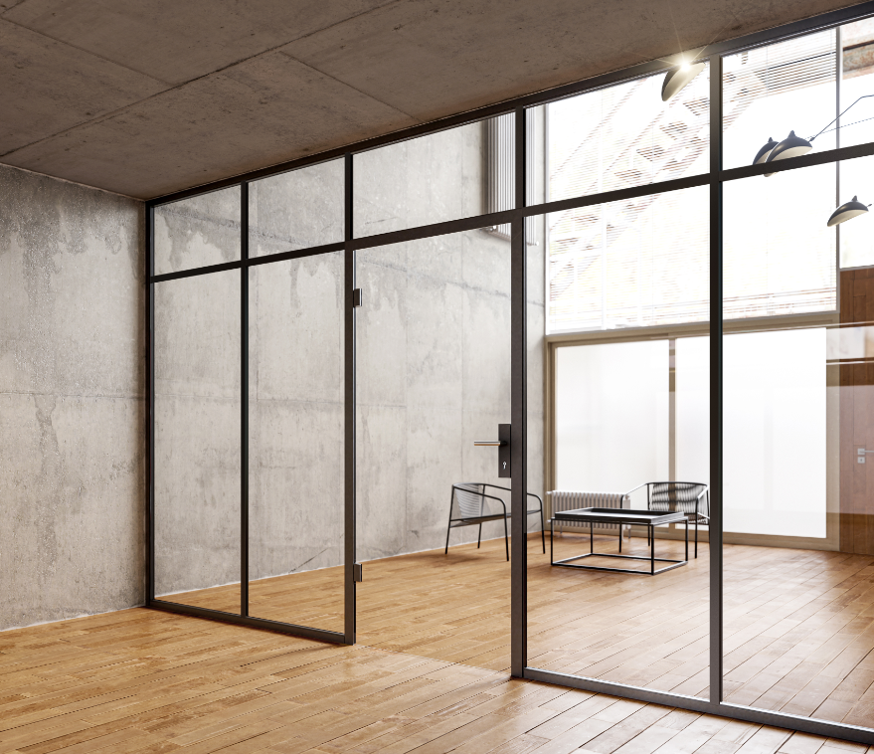

Dear Sir or Madam,

What used to be a sign of functional architecture has now become a trend: The industrial style has found its way into the furniture and decoration sector. And into the design of room partitions made of glass.

UNIQUIN decorative bars set strong visual accents

On large glass partitions as well as on glass doors, positioned within a glass wall or as separate doors in the masonry. As soon as the glass surfaces are divided with decorative bars, the entire ensemble takes on a new, strong look. It makes no difference whether the profiles are used within a UNIQUIN system or to visually enhance other, already existing glass walls and doors.

Creative, simple and deconstructable.

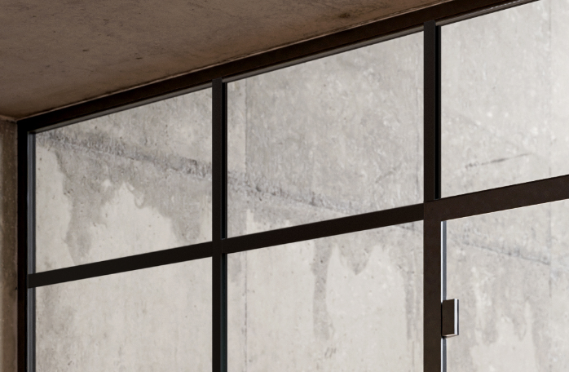

Everything is possible: uniform grids, accentuation of particular sections, graphic patterns, across the full height and width of the glass or optically floating. The covering of glass gaps between two adjacent glass panels is another option. There are almost no limits to creativity.

The basis for the new or redesigned look is 3 mm flat and 35 mm wide powder-coated aluminium profiles. They are cut from stock lengths of 2960 mm directly on site. When fitting on doors in rebated frames, the free glass edge on one side must be taken into account for the fitting to the door seal. Any visible cut edges can be adapted to the color of the powder coating using an optionally available touch-up pen.

Mounting on the glass is very simple: double-sided adhesive tape holds the profiles securely in place. And anything that is no longer to your liking can also be removed later.

For detailed information please see our Two-Pager UNIQUIN decorative bars.

Do you have any questions?

Please contact our regional sales representative. We will be pleased to help you further.

Contact / Signature

With best regards

DORMA-Glas GmbH

